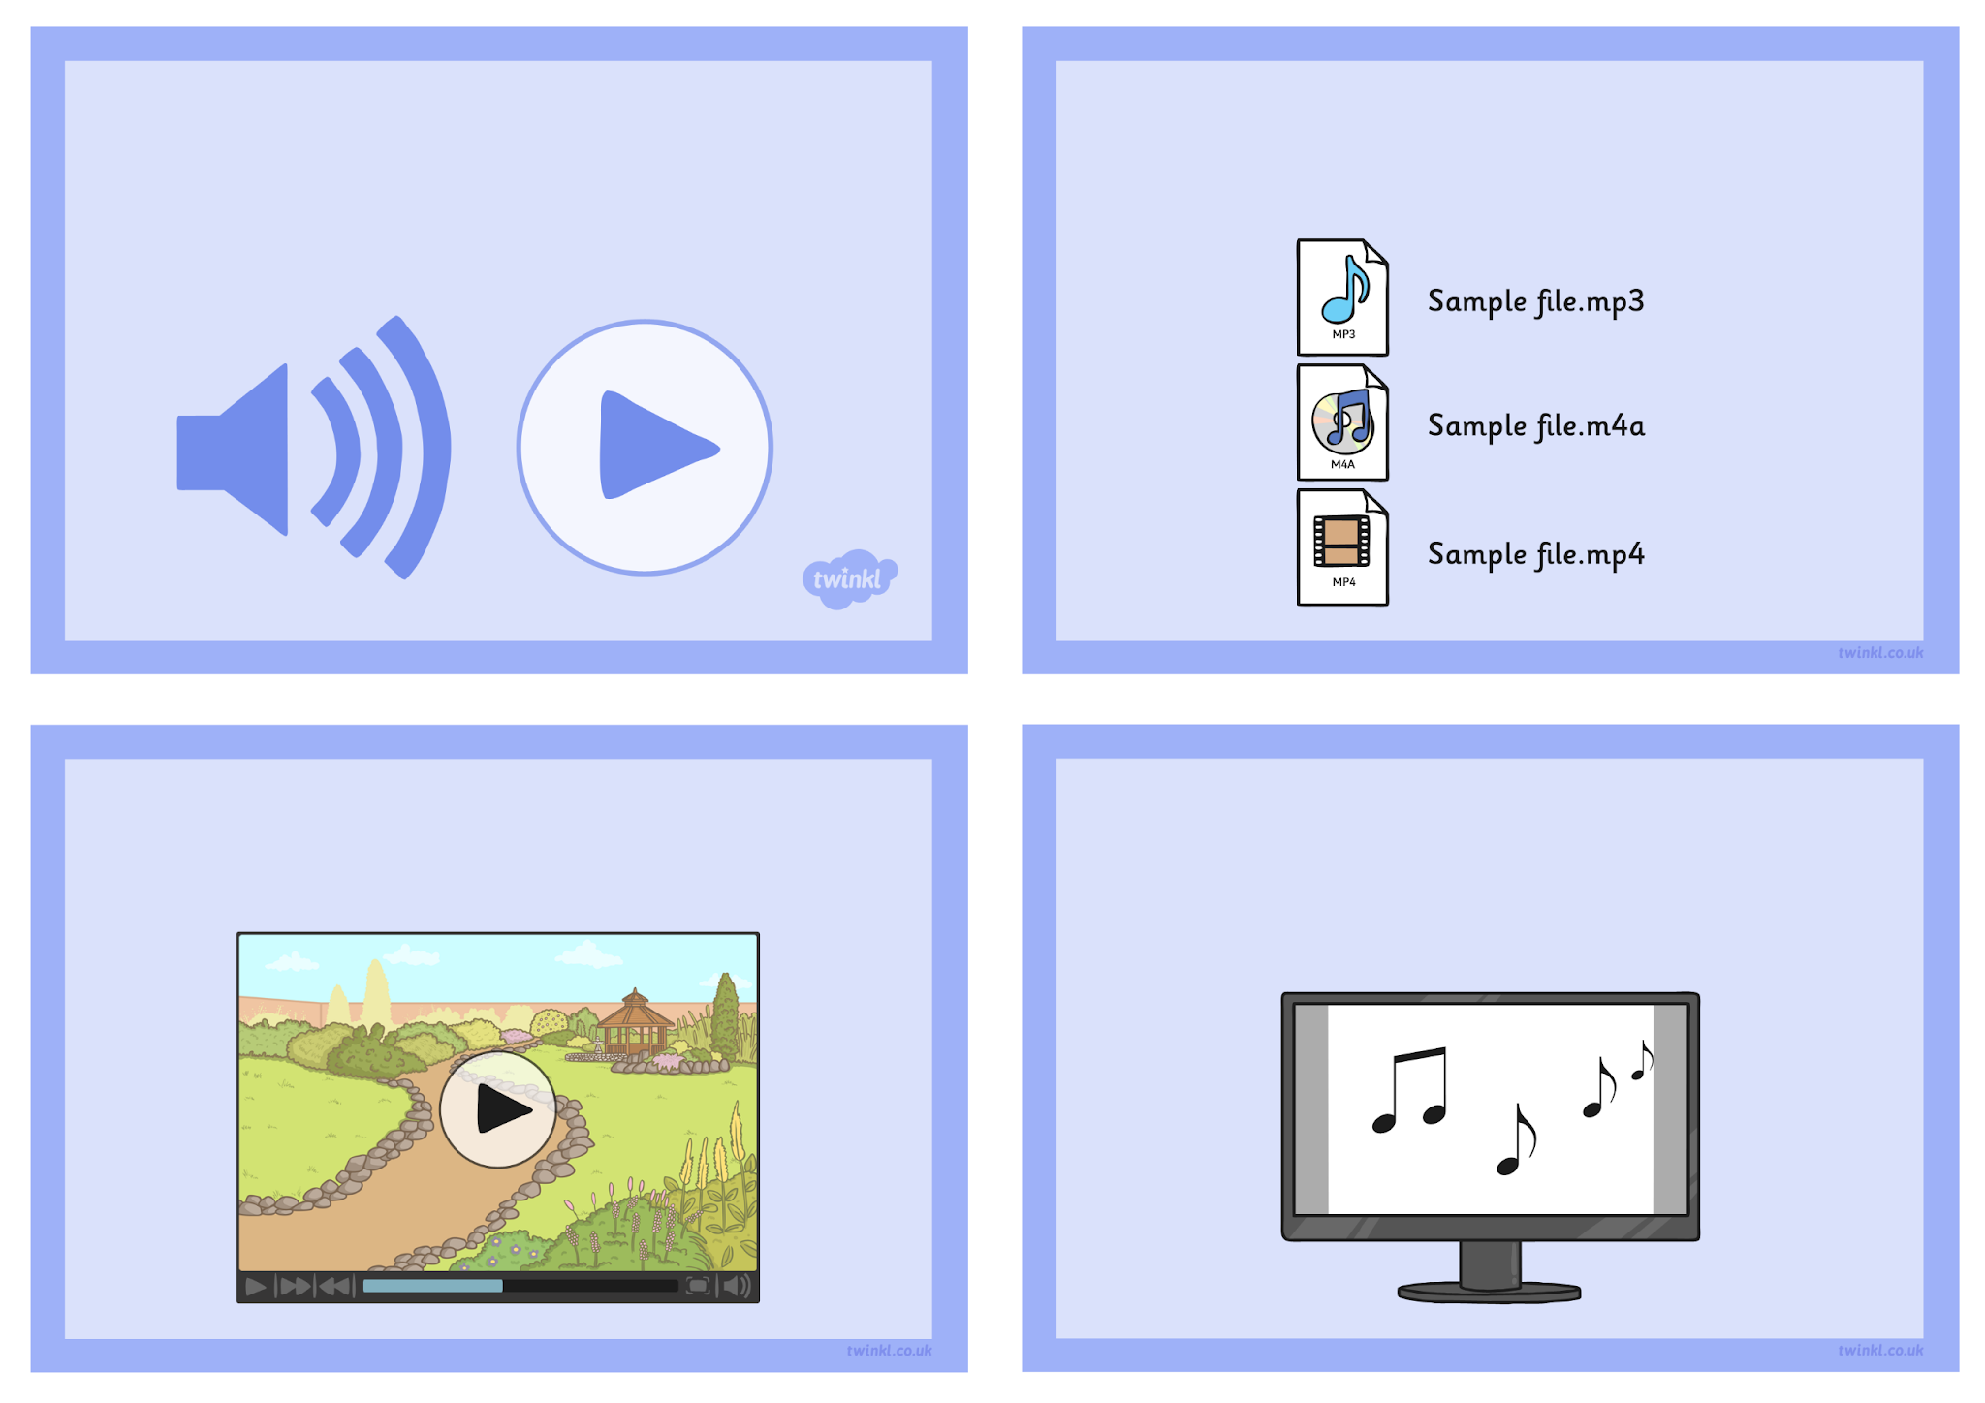
Audio and Video
Challenge Cards
Take the set of audio files and see which ones can be embedded into your presentation application.
Take a set of video files and see which ones can be embedded into your presentation application.
Choose a song you like. Find the words and copy them onto several presentation slides. Find a sound file of the song and insert this into the presentation and set it to play over all the slides.

Record a simple sound file of counting up to 10. Can you make a presentation with the numbers 1 to 10 on a different slide with this sound file where the slide transitions are timed to follow the counting.

